Write a program to solve a Sudoku puzzle by filling the empty cells.

A sudoku solution must satisfy **all of the following rules**:

1. Each of the digits 1-9 must occur exactly once in each row.
2. Each of the digits 1-9 must occur exactly once in each column.
3. Each of the digits 1-9 must occur exactly once in each of the 9 3x3 sub-boxes of the grid.

The '.' character indicates empty cells.

**Example 1:**

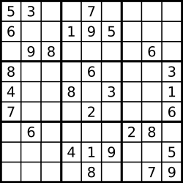

Input: board = [["5","3",".",".","7",".",".",".","."],["6",".",".","1","9","5",".",".","."],[".","9","8",".",".",".",".","6","."],["8",".",".",".","6",".",".",".","3"],["4",".",".","8",".","3",".",".","1"],["7",".",".",".","2",".",".",".","6"],[".","6",".",".",".",".","2","8","."],[".",".",".","4","1","9",".",".","5"],[".",".",".",".","8",".",".","7","9"]]  
Output: [["5","3","4","6","7","8","9","1","2"],["6","7","2","1","9","5","3","4","8"],["1","9","8","3","4","2","5","6","7"],["8","5","9","7","6","1","4","2","3"],["4","2","6","8","5","3","7","9","1"],["7","1","3","9","2","4","8","5","6"],["9","6","1","5","3","7","2","8","4"],["2","8","7","4","1","9","6","3","5"],["3","4","5","2","8","6","1","7","9"]]  
Explanation: The input board is shown above and the only valid solution is shown below:

**Constraints:**

* board.length == 9
* board[i].length == 9
* board[i][j] is a digit or '.'.
* It is **guaranteed** that the input board has only one solution.